## Lesson 7 – Activity Sheet

## Getting Started

Take your speaker or pair of headphones and wire them up as shown in diagram below

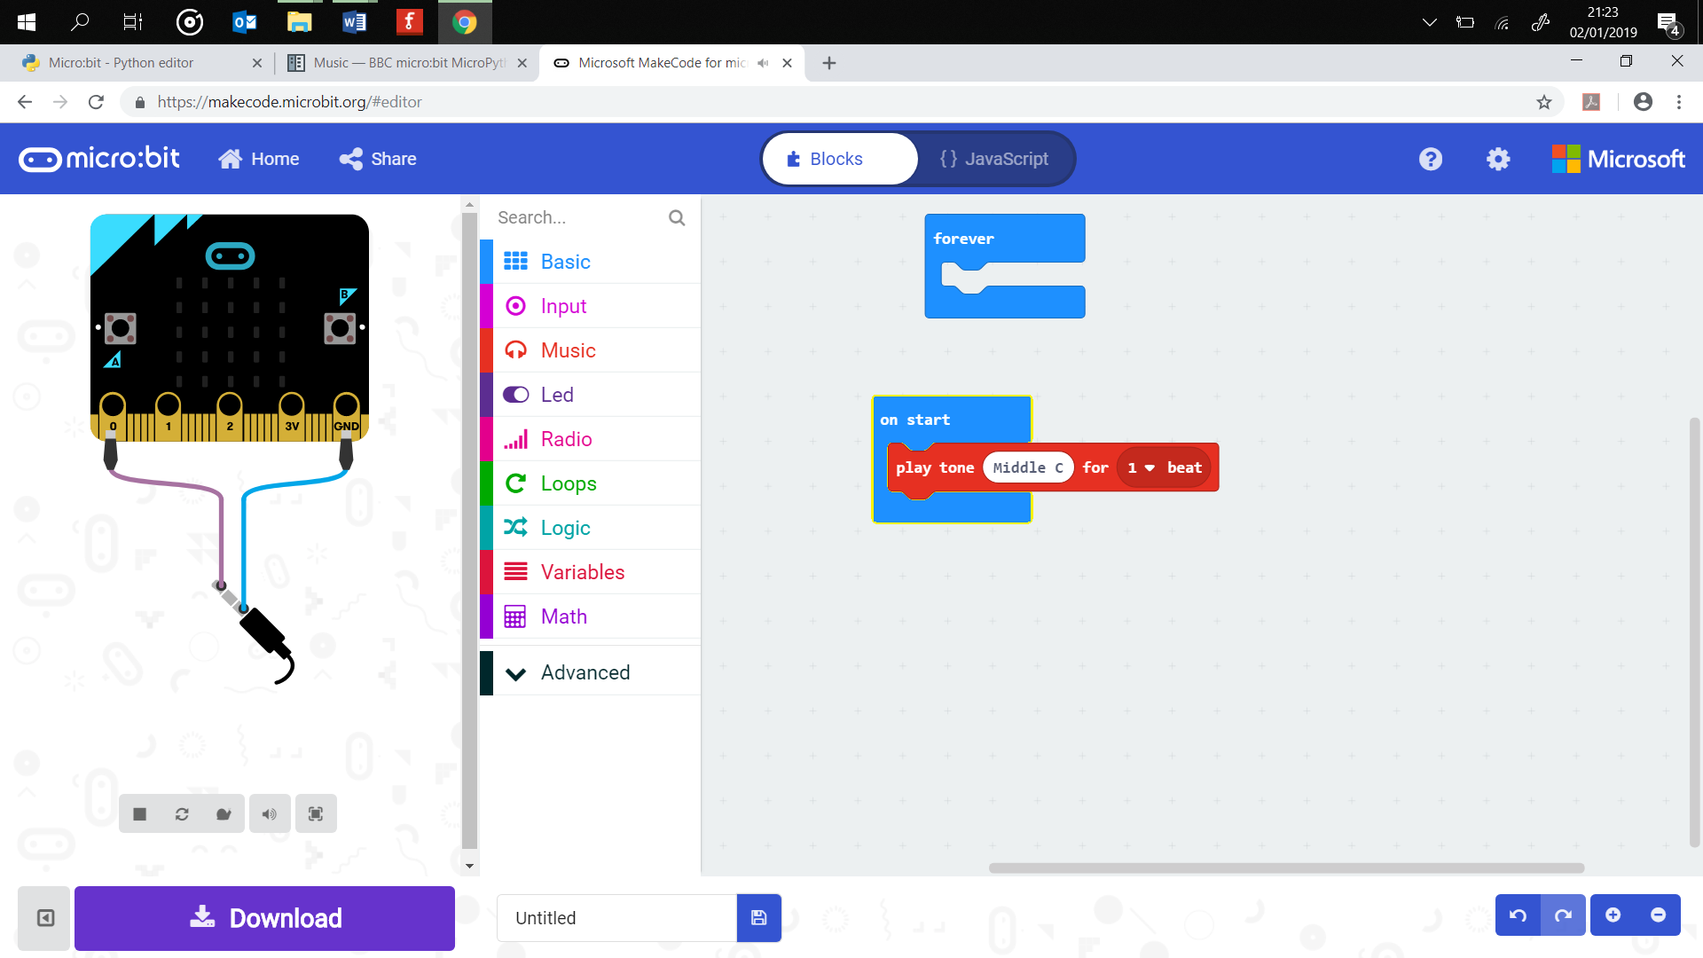

This enables you to play sounds and music via the micro:bit to an audio output. Now let’s test the speaker and play a pre-written piece of music. Enter the code shown below and download it to your micro:bit. Notice that it uses the music module which is imported, giving you access to the lines of code to control the music.

# Add your Python code here. E.g.

from microbit import *

import music

music.play(music.NYAN)

Do you recognise the song? Why not try some of these? Simply replace the music.NYANwith a choice from the list below:

music.DADADADUM, music.ENTERTAINER, music.PRELUDE, music.ODE, music.RINGTONE, music.FUNK, music.BLUES, music.BIRTHDAY, music.WEDDING, music.FUNERAL, music.PUNCHLINE, music.PYTHON, music.BADDY, music.CHASE, music.BA_DING, music.WAWAWAWAA

## **Writing your own music**

Music is made up of notes, A, B, C, D, E, F, and G and then you can have sharp or flat versions of these notes, such as A#, B#. C#, D# E# or A*b,* B*b*, C*b*, D*b* and so on.

For example, C4, is known as middle C, the same note as middle C on a piano. It is the note C played at the fourth octave. We can increase the octaves between a range of 0 and about 8, any higher and our ears cannot hear the notes, but cats will!

We can also set how long the note plays for, for example C4:8 lasts for twice as long as C4:4. Finally, we can add a pause between notes by using the note R, followed by the duration, for example R:2 is a rest or pause of 2.

Ready, then let us compose.

## **Creating your own film sound effects or sound track**

Think of a superhero or a film and then image the type of music that would be used. If you are not sure then you can always think of your favourite theme tune or song. You are going to compose the theme tune or soundtrack for the film. Use the code below.

import music

tune = ["C4:4", "D4:4", ADD YOUR NOTES]

music.play(tune)

The program also uses a list named tune which holds the data about the notes. The list stores the note to be played, the octave and the duration of the note. Each note is expressed as a string of characters, NOTE[octave][:duration], for example, "C4:2" refers to the note C in octave number 4 to be played for a duration of 2. Remember you can also add pauses. You can add pauses using the code R

## Success Criteria

* Create a simple theme tune using the pre-made music
* Compose your own theme tune using notes
* Create two or more themes which are played when the buttons A or B pressed
* Use two micro:bits to create a musical harmony

## Pro-tip

Use your web browser to reference the piano layout and the frequencies of each note.

Try and make use of the rest code as this adds pauses to your melody and will improve the overall feel of the music that you have created.

You can create a number of lists which hold your theme tune and notes, these can be assigned to button A and B. Look at the example code below,

tune = ["C4:4", "D4:4", ADD YOUR NOTES]

tune2 = ["C8:4", "E4:4", ADD YOUR NOTES]

while True:

if button_a.is_pressed():

music.play(tune)

elif button_b.is_pressed():

music.play(tune2)

## Test Time

Download your program to your micro:bit and have a listen to your them. You may need adjust the notes and timings several times to perfect your melody.

## Stretch tasks

* Use the buttons on the micro:bit to trigger the music to play
* Create a music quiz, press a button and a song is played. Can other learners guess what the song is?

## Final thoughts

In this lesson we have covered:

* Lists
* Playing music
* Composing music

You have combined these to create a theme tune or melody for a superhero or other event. Think about how you can make the music sound even better? Add more parts, could you combine several micro:bits to create a micro:bit orchestra? Perhaps you could put on a live performance?